The University of Azad Jammu and Kashmir, Muzaffarabad

Name :Alishba Zakir
Roll No: 2024-SE-02
Course: Computer Networks
Course Code: SE-2203
Lab : LAN
Submitted To: Engr. Dr. Asma Javaid
Submitted By: Alishba Zakir
Date : 31 Mar, 2026

Department Of Software Engineering
How to connect two switches to form a LAN
This is a Star-Bus hybrid topology consisting of two interconnected local network segments.
Key Components
- Infrastructure: Two Cisco Catalyst 2960-24TT switches linked together.
- End Devices: A total of 5 PCs distributed across the switches (3 on Switch0, 2 on Switch1).
- Connectivity:
  - Solid Black Lines: Represent Copper Straight-Through cables used to connect the PCs to the switch ports.
  - Dashed Black Line: Represents a Copper Cross-Over cable used for the switch-to-switch connection (standard for connecting like-devices in older simulations).
- Status Indicators: All link lights are Green (▲), indicating that the physical layer connections are active and the ports are currently in a "Forwarding" state.
Functional Summary
The configuration creates a single, extended LAN (Local Area Network). Because the switches are bridged together, all 5 PCs are in the same broadcast domain, allowing them to communicatewith one another once IP addresses are configured. 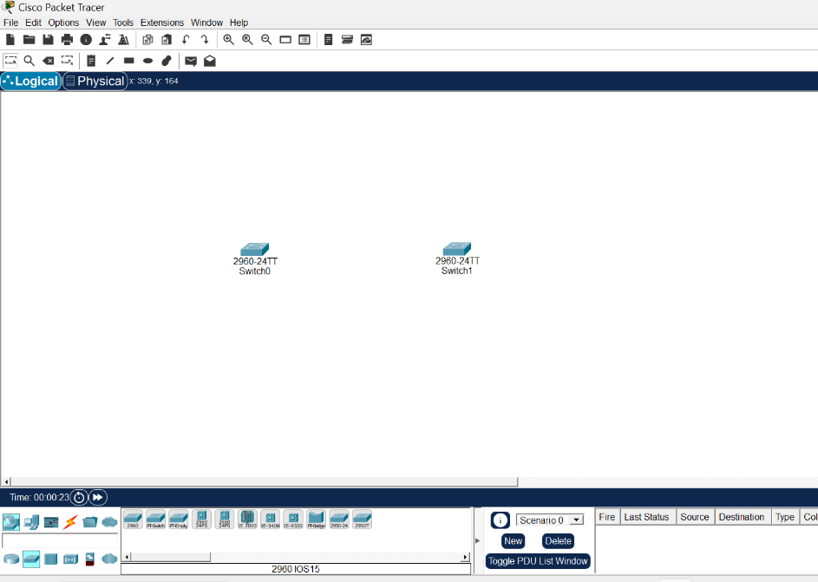
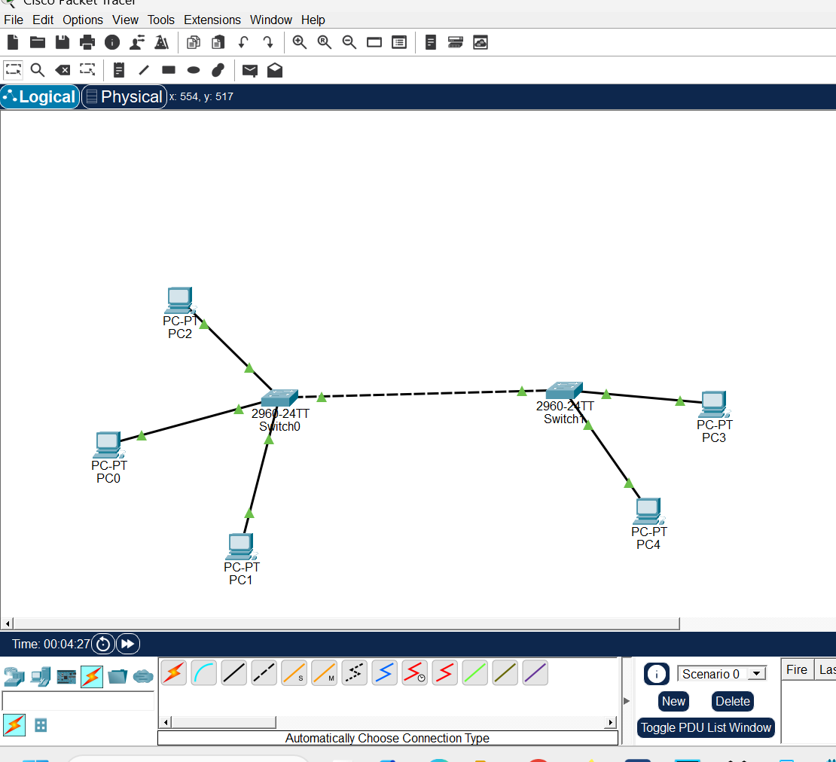

- IP Configuration 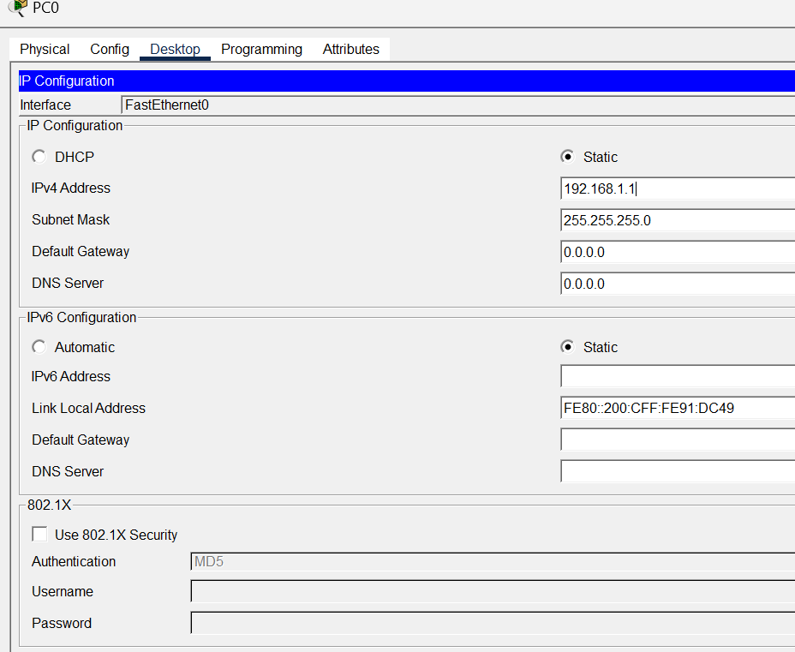

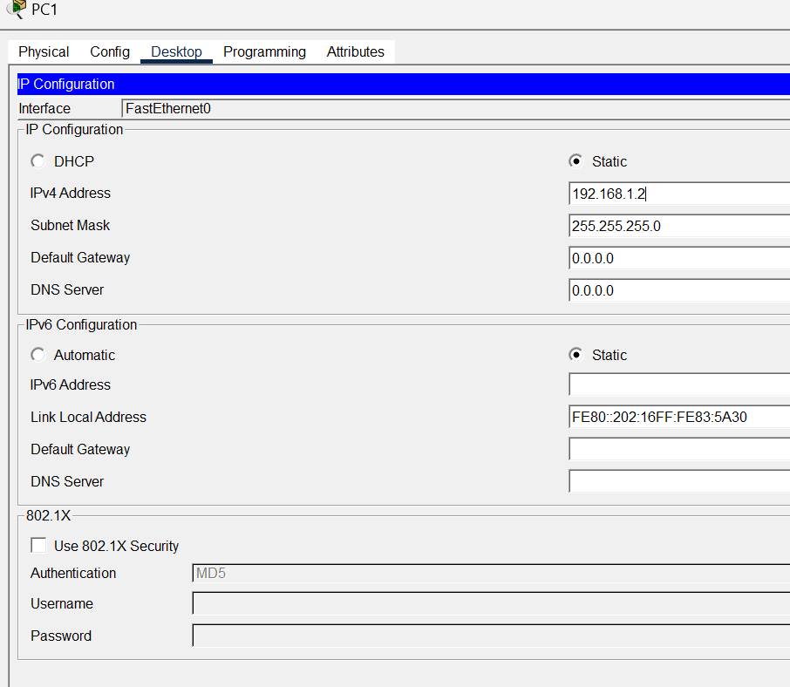

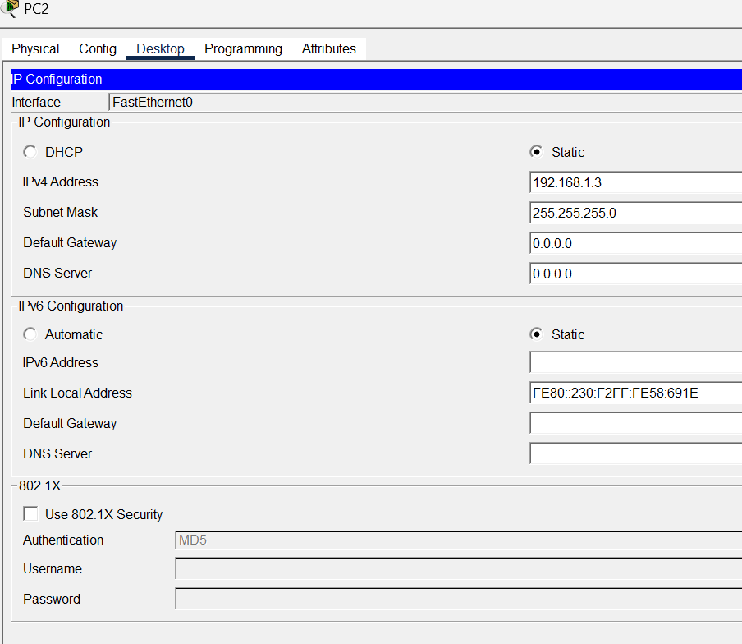
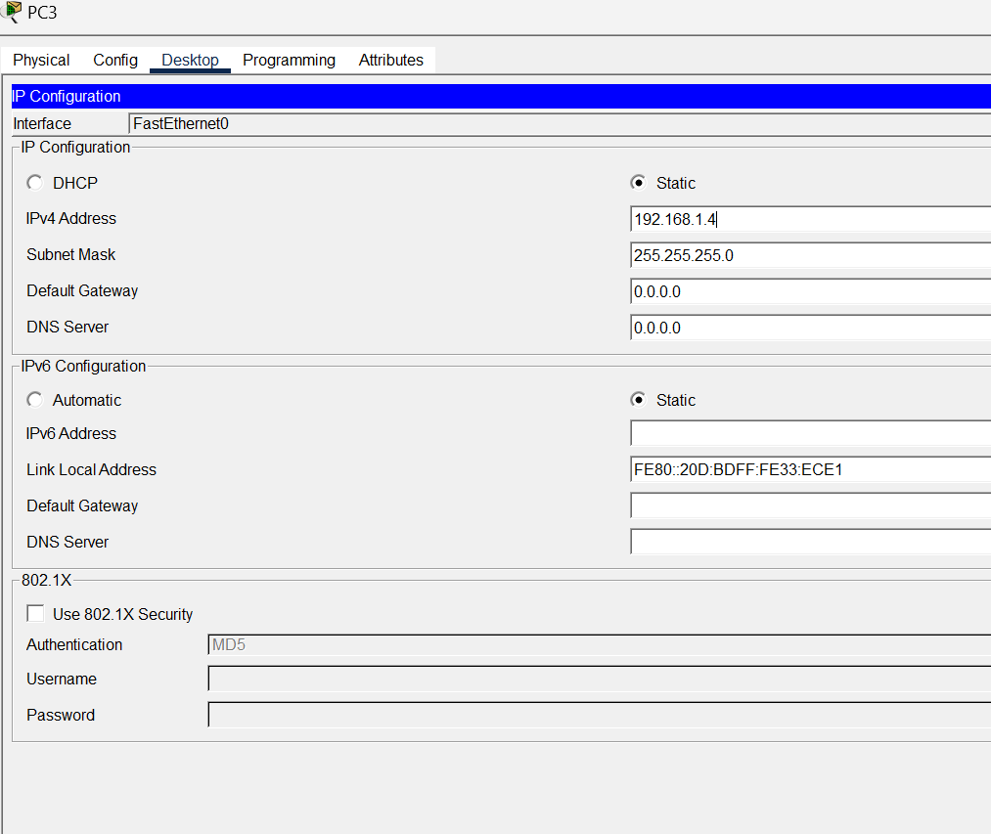

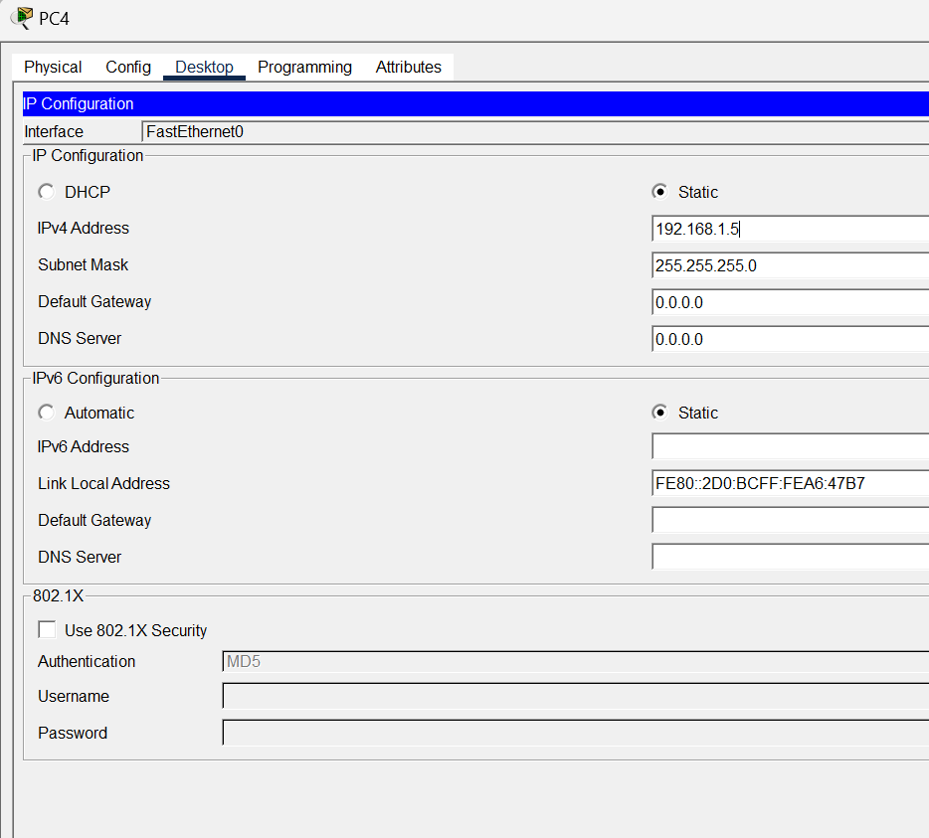

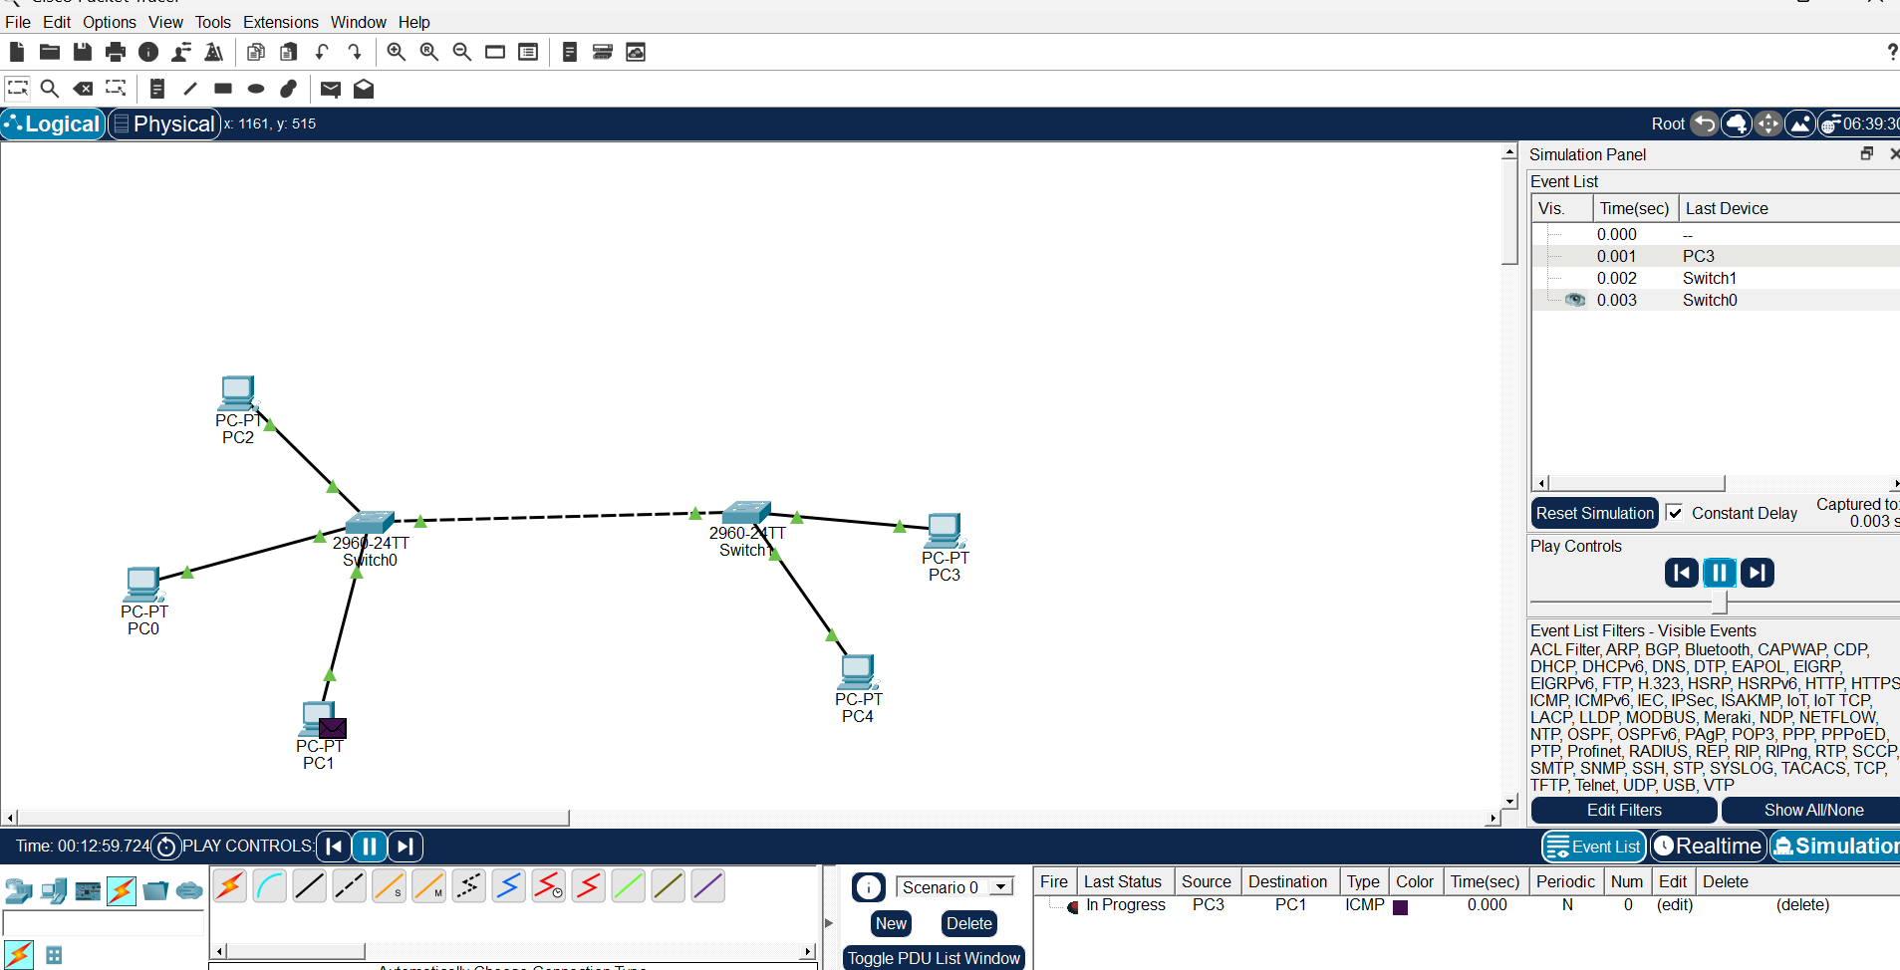
- Network Topology: The setup includes five PCs connected to two Cisco 2960-24TT switches. Switch0 connects to PC0, PC1, and PC2, while Switch1 connects to PC3 and PC4. The two switches are linked together via a dashed line, indicating a Crossover Cable.
- Simulation Panel: On the right, the "Event List" tracks network traffic in real-time. It shows a sequence of events starting from PC3, moving through Switch1, and arriving at Switch0.
- PDU Information: At the bottom, the "User Created PDU" window shows an active ICMP (Ping) request. The source is PC3 and the destination is PC1, with the status currently "In Progress."
- Visual Indicators: The green triangles on the connection lines signify that the link lights are "up" and active, though a purple envelope icon on PC1 indicates it is the target of the current simulation packet.

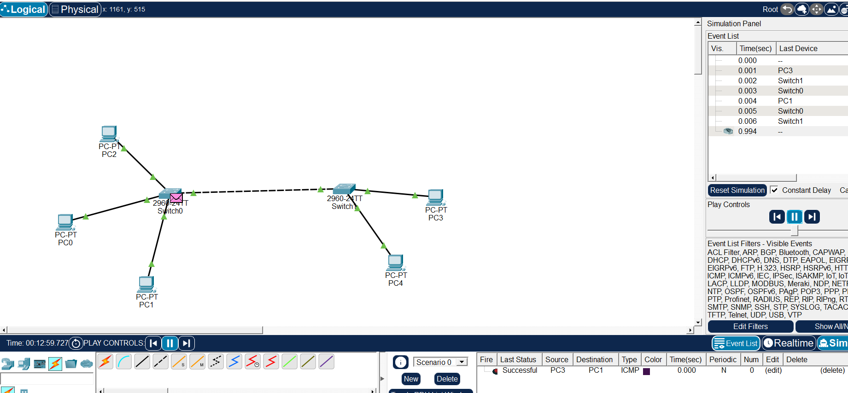

Simulation Overview
- Action: An ICMP (Ping) packet is being sent across the network.
- Visual Indicator: A purple envelope icon is visible on Switch0, indicating the packet is currently in transit through that specific device.
- Scenario Result: The bottom right "PDU List" window shows a status of "Successful" for an ICMP traffic flow from Source: PC3 to Destination: PC1.

Physical View : 